KUKA Group and KOMSA Enter Strategic Partnership: Making Automation More Accessible for Small and Medium-Sized Businesses
- Partnership aims to simplify access to mobile robotics and automation solutions, particularly for small and medium-sized enterprises (SMEs)
- KOMSA expands its technology portfolio with KUKA Group's Autonomous Mobile Robots (AMRs)
- New sales model creates additional growth opportunities for IT resellers and system integrators in the automation market

Hartmannsdorf / Augsburg / Berlin, October 22, 2026 – KOMSA GmbH, one of the leading technology distributors in the DACH region, and KUKA Group, one of the world's leading robotics and automation companies, today announced the launch of a strategic partnership focused on Autonomous Mobile Robots (AMRs). Together, the companies aim to make intelligent automation more accessible and unlock new customer segments across Germany.
As part of the partnership, KUKA Group contributes its portfolio of mobile robotics solutions as well as its extensive automation and robotics expertise. KOMSA complements these strengths with established sales structures, a broad network of reseller, systems integrator, and channel partners, and many years of experience in introducing and scaling new technologies through indirect sales channels. The shared objective is to make automation easier to access, integrate, and scale for a wider range of businesses. In particular, the partnership is designed to lower the barriers to adopting mobile robotics for SMEs. At the same time, it enables IT resellers and system integrators to expand their existing solution portfolios with automation technologies and tap into new business opportunities.
Automation Becomes Relevant for New Customer Segments
Artificial intelligence, robotics, and automation are becoming increasingly relevant for businesses of all sizes far beyond traditional industrial applications. Labor shortages, rising costs, and growing demands for efficiency and flexibility are driving adoption. As a result, the SME sector represents significant potential for easy-to-deploy, scalable solutions, particularly in material handling and logistics processes. Autonomous Mobile Robots can provide an accessible entry point into automation while complementing existing operations with greater flexibility.
"With KUKA, we are gaining a global market leader as a partner that shares a similar DNA and our vision of bringing robotics and automation to a broader market and enabling small and medium-sized businesses to implement these technologies easily and with measurable results. Our strong partner network and technical expertise are key success factors. What we have successfully built over decades in the telecommunications sector, we are now transferring to mobile robotics."
Steffen Ebner, CSO, KOMSA GmbH

"Automation is becoming a critical driver of productivity and competitiveness for an increasing number of businesses. Particularly in the SME sector, we must continue to reduce barriers to adoption. Together with KOMSA and its partner ecosystem, we aim to make modern automation more accessible and scalable. Physical AI further expands the range of potential applications, industries, and customer groups. The key is to translate these opportunities into practical solutions that deliver measurable value for end customers."
Raphael Hegeler, Senior Vice President Corporate Strategy & New Business, KUKA Group
The launch of a dedicated product and service portfolio is supported by a joint partner program, including training and certification offerings. As the Center of Competence for KUKA Group's mobile robotics solutions, KOMSA will support selected channel partners throughout their projects as needed, from planning, implementation, and commissioning through to final customer acceptance. Initial pilot projects are already underway.
Images:

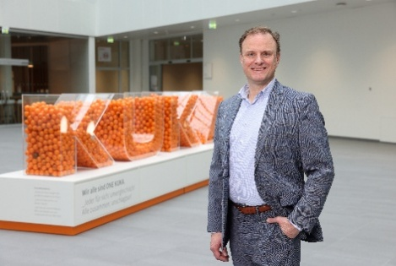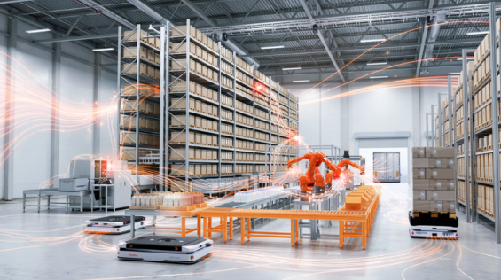
Raphael Hegeler, Senior Vice President Corporate Strategy & New Business, KUKA Group © KUKA Group

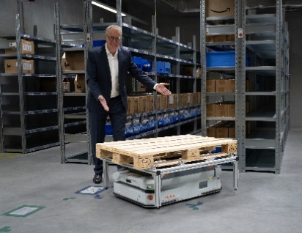
Steffen Ebner, CSO, KOMSA GmbH © KOMSA /
Steffen Ebner, CSO, KOMSA GmbH, with the KUKA KMP 600P, which is deployed within KOMSA's own logistics operations

KOMSA Group

KOMSA Group, headquartered in Hartmannsdorf, Germany, is one of Europe’s leading technology distributors. With around 850 employees and annual revenues of approximately EUR 1.2 billion, the company connects manufacturers, network operators, and other industry partners with consumer, business, and enterprise customers through a partner ecosystem of more than 10,000 resellers across multiple sales channels. KOMSA’s portfolio spans traditional distribution, value-added and managed services, as well as innovative Device-as-a-Service (DaaS) solutions, enabling sustainable growth and digital transformation for its partners.

KUKA Group
KUKA Group is shaping the next era of automation — a future where intelligent machines seamlessly understand, adapt, and collaborate with their environment. As a global leader in automation solutions with EUR 3.9 billion in sales and around 14,500 employees, KUKA Group combines more than a century of innovation with technologies that help customers increase efficiency, scale automation with ease, and stay resilient in a fast-changing world. KUKA Group’s portfolio spans industrial automation, intralogistics, and warehouse automation, offering products, solutions, services, and software & AI that empower customers across diverse sectors — from automotive and electronics to metal processing, manufacturing, retail & ecommerce, FMCG & CPG, healthcare & life sciences, aerospace and education. KUKA Group is operating globally in more than 50 countries and headquartered in Augsburg, Germany.

KOMSA GmbH Internet:
Presseteam www.komsa.com
KOMSA Allee 1
09232 Hartmannsdorf e-Mail:
Tel.: 03722/713-750 presse@komsa.com

